Stats:
Height: 5’7”- Size 14
Hair: Blonde
Eyes: Blue
Age Range: 45-60
Diane Thiemann
SAG Eligible
Big F ish Talent Agency
303-744-7174
www.bigfishtalent.com
Dimithiemann@aol.com
Cell: 720-235-3124

Television/FILM
House in Windsor (Short) Carol Pretty People Productions
Gathering of Heroes Healer Asgard Films/ Mark Grove/Dir.
“Nine Seconds of Light” (Film) Anne Colburn Nick Gossart/Director
“11:59” (Film) Farmer’s Wife Double Edge Films/Jamin Winans
“The Maze” (Film) Professor’s Wife Double Edge Films/Jamin Winans
“Busted” ,Animal Planet Jeannette LaBove Rocket Pictures/Discovery CH.
“Encounters of the Unexplained” Mrs. Johnson ShadowPlay Prod./PAX TV
“Legend of Colorado” Saloon Girl Dirk Olsen, Director, PBS-DCPS
Perry Mason Secretary Viacom Productions
Diagnosis Murder Policewoman Viacom Productions

Commercials/Industrials
(Over 100 commercials, industrials, and voice over listings on request)

Stage
“And Then There Was Nun” Marilyn Monroe The Vintage Theater/Peter Hughes
“High Society” Ensemble Performance Now Company
“Steel Magnolias” Truvy EProject Theater
“In the City”-“Fur” Mrs. Diana Hunter Brooks Center Arts Theater
“Santos and Santos” Peggy Willis El Centro Su Teatro, Phil Luna
“Opal’s Baby” Principal Tyler Civic Theater
“The Savage Dilemma” Principal Tyler Civic Theater
“The Second Time Around” Eleanor Tyler Civic Theater
“Diamonds in the Tough” Rose Haydee Wakely (lead) 4 Mile Historic Park Prod/CO
“Bread and Roses” Helen O’Leary, Percy, M’Lady 4 Mile Historic Park Prod/CO
“Women Beating the Odds” Millie Booth (lead) 4 Mile Historic Park Prod/CO

Training
Film/Commercial Acting: Molli Benson, Doug Lenzini, Benson Studio, Peter DeAnello
Film Acting/Theater Workshops: Brad Wilson, Mike Fenton, Tony Barr, Dabney Coleman, Lee Purcell, Dan Lauria, Cliff Osmond, Ben Murphy, Marc D’urso,
Voice Over/Voice/Singing Voice: DCPA,Scientific & Cultural Facilities, Christy Wessler, Rick Paswaters
North Texas State University, Denton, Texas- B.A in Drama-Speech Communication, Speech Pathology

special awards- Benson Awards 1984 Best Supporting Actress (Regional) Benson Productions
Benson Awards 1985 Nominee for Best Actress (Regional) Benson Productions

Special Skills-
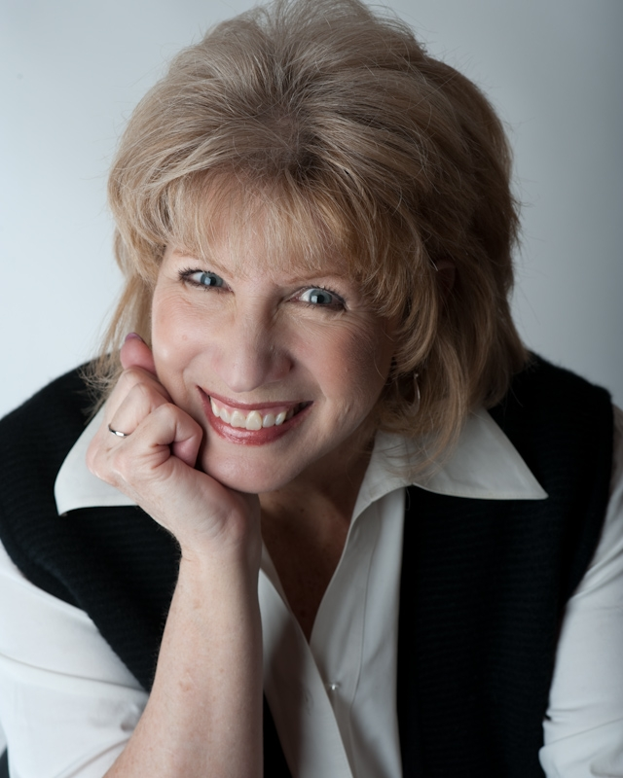
The Ear prompter, Dance(jazz, tap, ballet, ballroom basic, C&W),
choreographer/ instructor; vocalist, basic Spanish;
Dialects: French, Southern, German, Irish
sports-Basic stunt work, snow skiing, horseback riding, bowling,
swimming, billiards, snorkeling, scuba diving(certified), golf

